COMPARATIVE TIME SERIES ANALYSIS AND FORECASTING OF STOCK RETURNS: A CASE STUDY OF MTN NIGERIA AND DANGOTE CEMENT (2020 – 2025)

BY
GROUP 2
Surname | Name
- Aladoye | Grace
- Adejumo | Tosin
- Jimoh | Teslim Abiodun
- Komolafe | Fatai Abiodun
- Olaniyan | Elizabeth

ABSTRACT
Stock markets play a vital role in the economic stability and growth of any nation, serving as a barometer for economic performance and a medium through which companies raise capital. In Nigeria, companies like MTN Nigeria and Dangote Cement are among the most capitalized on the Nigerian Exchange (NGX), drawing the attention of both local and foreign investors. Understanding and predicting their stock performance, especially returns, is critical for informed investment decision-making. This study seeks to apply time series analysis to evaluate and forecast the daily stock returns of MTN Nigeria and Dangote Cement over a six-year period using historical closing price data.
The analysis begins with an exploratory data assessment to understand the underlying distribution and trends in the dataset. Daily returns were computed from adjusted closing prices, and various visualizations including histograms, boxplots, and line graphs were used to assess volatility and return behavior. Stationarity of the return series was tested using the Augmented Dickey-Fuller (ADF) test, and ARIMA models were fitted using the auto.arima() function to determine the optimal forecasting models.
Forecasts for the next 30 trading days were generated, and the models were evaluated using residual diagnostics to ensure robustness and reliability. The results suggest that MTN’s returns demonstrate greater stability and lower volatility, making it a potentially safer investment in the short term. Dangote Cement, on the other hand, showed higher variability, suggesting higher risk but also the potential for higher returns. The forecasted returns, while not intended to predict exact future values, provide an evidence-based guide to short-term investor sentiment and potential market movements.
This research contributes to the growing literature on stock market analysis in emerging economies and offers practical implications for investors, fund managers, and policy makers who rely on short-term predictive models to inform portfolio decisions. Additionally, it showcases the importance and applicability of time series modeling in understanding market dynamics within the Nigerian context.

CHAPTER ONE

INTRODUCTION
The Nigerian stock market, like many in emerging economies, is characterized by moderate liquidity, high volatility, and limited transparency. In such a setting, informed decision-making becomes both critical and challenging for individual and institutional investors. Over the years, publicly traded companies such as MTN Nigeria and Dangote Cement have become cornerstones of the Nigerian Exchange due to their financial performance and market capitalization. Their shares not only attract a significant portion of domestic investors but also draw attention from international markets seeking exposure to Sub-Saharan Africa. With fluctuating stock prices influenced by various macroeconomic, political, and sector-specific factors, forecasting future stock returns has become a necessity for minimizing risk and optimizing returns.
Time series forecasting is one of the most robust and widely used approaches for predicting stock prices and returns. The autoregressive integrated moving average (ARIMA) model, in particular, is favored for its flexibility and ability to capture both trend and seasonality in time series data. Although past stock prices do not guarantee future movements, they often contain sufficient information to identify patterns and generate probabilistic forecasts. Thus, understanding how historical prices evolve over time is the starting point for building models that can simulate future behavior.
In this research, we aim to apply time series modeling techniques to analyze and forecast the stock returns of two of Nigeria’s top companies—MTN Nigeria and Dangote Cement—using data spanning a six-year period. We begin by transforming the raw price data into daily returns, which serve as the foundation for understanding the risk-return profile of each stock. The analysis includes descriptive statistics and visual tools to understand the structure and distribution of the returns. The Augmented Dickey-Fuller (ADF) test is used to determine the stationarity of the series, and suitable ARIMA models are fit to each return series based on AIC optimization. Forecasts for the subsequent 30 trading days are then generated, providing a short-term outlook for both stocks.
This study is significant not only for its academic contribution to time series modeling in financial analysis but also for its practical relevance to the Nigerian investment landscape. The insights derived will be of interest to retail investors, asset managers, and financial analysts looking to improve investment strategies through data-driven insights. Moreover, the comparative approach of analyzing both a telecom giant and an industrial heavyweight allows for a deeper understanding of sectoral behavior in the Nigerian market. Ultimately, this research intends to bridge the gap between statistical forecasting and real-world financial decision-making in Nigeria.

Background of the Data
This research utilizes stock price data for two prominent companies listed on the Nigerian Stock Exchange (NSE): Dangote Cement and MTN Nigeria. Dangote Cement is one of the largest cement manufacturers in Africa, while MTN Nigeria is a leading telecommunications company in the country. Both companies are integral to the Nigerian economy, representing two of the most significant sectors—cement manufacturing and telecommunications.
The data set consists of daily closing stock prices for Dangote Cement and MTN Nigeria over a six-year period. The data is sourced from reputable financial databases, ensuring its accuracy and reliability. The time series data spans from [2020] - [2025], providing a comprehensive view of the stock performance during this period.
The choice of this period is driven by the need to analyze a sufficient number of data points for both companies, allowing for a robust analysis of trends, patterns, and volatility in stock prices. The data is structured with the following key columns: Date, Dangote Close, and MTN Close. The Date column represents the daily trading day, while the Dangote Close and MTN Close columns capture the closing prices of Dangote Cement and MTN Nigeria stocks for each respective day.
The stock data is analyzed to calculate the daily returns of both companies, which represent the percentage change in stock prices from one day to the next. These returns are essential for understanding the daily fluctuations in the stock price, which is crucial for investors seeking to predict future stock performance and make informed investment decisions.

Aim and Objectives
- This research aims to analyze the stock returns of Dangote Cement and MTN Nigeria using time series analysis. By forecasting future returns with ARIMA models, the study seeks to provide insights into the performance of these stocks and help investors make informed decisions in the Nigerian stock market.

- Objectives are:
- Examine the Stock Return Behavior of Dangote Cement and MTN Nigeria:
- Evaluate the Stationarity of Stock Returns:
- Fit ARIMA Models for Forecasting:
- Perform Model Diagnostics:
- Generate and Visualize Forecasts:
- Compare Stock Return Characteristics:
- Provide Recommendations for Investors:

Significance of Study
This research provides investors with an empirical analysis of two major Nigerian companies, aiding in decision-making and risk management. By applying time series analysis and forecasting techniques, the study offers actionable insights into the expected behavior of stock returns for Dangote Cement and MTN Nigeria. Furthermore, the findings can contribute to the growing body of knowledge in financial data analysis, specifically in emerging markets like Nigeria, where market prediction remains a challenge.

CHAPTER TWO

LITERATURE REVIEW

2.1 Introduction
Stock market forecasting has long been a significant area of interest in finance and economics due to its potential to inform investment decisions, manage risks, and understand market dynamics. Time series models such as the Autoregressive Integrated Moving Average (ARIMA) have remained dominant tools for modeling and forecasting financial time series due to their capacity to capture patterns, trends, and seasonality.
According to Box and Jenkins (1976), the ARIMA model is highly effective for short-term forecasting in non-stationary time series by first differencing the data to attain stationarity. In recent times, several studies have applied ARIMA to forecast stock prices and returns, with mixed results depending on the data characteristics and model parameters. For instance, Gujarati and Porter (2009) highlight that the effectiveness of ARIMA models heavily relies on correct model identification and diagnostic checking.
In Nigeria, the performance of companies such as MTN Nigeria and Dangote Cement has significant implications for the country’s stock market index and investor confidence. MTN Nigeria, a major player in the telecommunications industry, and Dangote Cement, a key player in the industrial sector, are both included in the Nigerian Stock Exchange’s Premium Board. Studies such as Ologunde et al. (2006) and Olowe (2011) have examined the volatility and trends in Nigerian stock returns, indicating that local macroeconomic variables and global economic trends play a vital role in shaping stock behaviors.
However, few studies focus on weekly or daily returns for long durations (over five years), and even fewer combine exploratory data analysis, return distribution visualization, and forecasting in one comprehensive study. This research, therefore, attempts to fill this gap by applying robust exploratory and forecasting methods on daily return data of MTN and Dangote Cement over a six-year period, using advanced tools in R programming to generate insights, test for stationarity, and predict future returns.

CHAPTER THREE

DATA AND METHODOLOGY

3.1 Data Description
The dataset used in this study consists of daily closing prices for two major Nigerian stocks: MTN Nigeria and Dangote Cement, spanning a period of six years. The data comprises three columns:
- Date: Representing the trading day.
- MTN_Close: Daily closing price of MTN stock.
- Dangote_Close: Daily closing price of Dangote Cement stock.
The dataset was sourced from financial archives and converted into a structured CSV format suitable for time series analysis.

3.2 Data Preparation
Before any meaningful analysis, the raw data was cleaned and transformed:
- The Date column was parsed into standard date format using parse_date_time() to handle various date entry styles.
- The dataset was sorted chronologically using arrange(Date).
- Column names were renamed to MTN_Close and Dangote_Close for clarity.
- Missing or infinite values were filtered out after calculating returns to ensure robustness of analysis.

3.3 Calculation of Returns
To standardize comparisons and model financial behavior, Daily Returns were computed using the formula:
$${Return}_{t}= \left(\frac{P_{t} - P_{t - 1}}{P_{t - 1}}\right) × 100$$
Where:
- $P_{t}$​ = Price of the stock at time t (today's closing price)
- $P_{t - 1}$​ = Price of the stock at time t−1 (previous day's closing price)
This helps to measure relative changes in price and enables volatility analysis.

3.3.1 Daily Return Over Time Graph
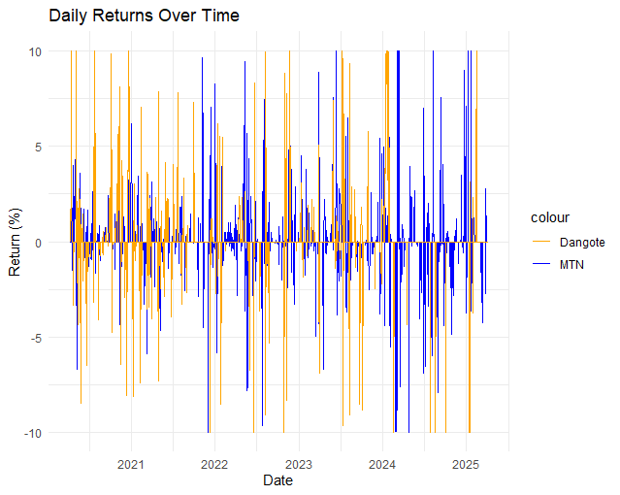

3.4 Exploratory Data Analysis (EDA)
A thorough EDA was conducted to understand the structure, distribution, and quality of the data before daily return was calculated using tools such as:
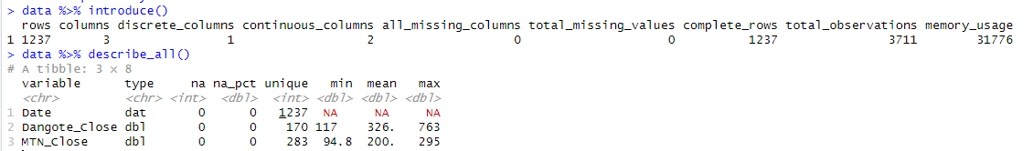
- introduce() and describe_all() for dataset summary.

- Summary Statistics
MTN_Return Dangote_Return
Min. :-10.0000 Min. :-10.0000
1st Qu.: 0.0000 1st Qu.: 0.0000
Median : 0.0000 Median : 0.0000
Mean : 0.0962 Mean : 0.1365
3rd Qu.: 0.0000 3rd Qu.: 0.0000
Max. : 10.0000 Max. : 10.0000

- plot_density() and plot_histogram()to explore return distribution.
- explore_all() to get a holistic overview of the dataset.

3.4.1 Explore all
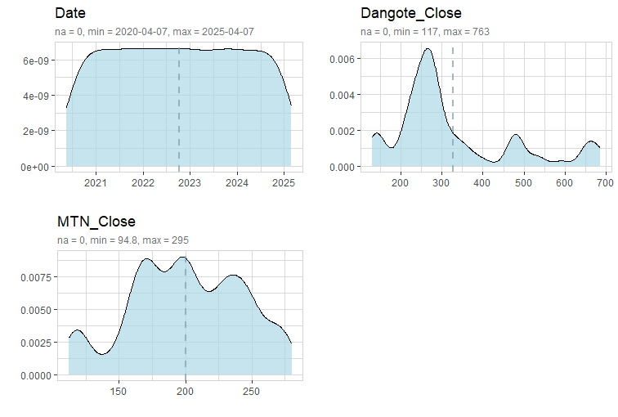

Visualizations included (after Daily Returns Calculation):

3.4.2 Histograms: To assess the skewness and kurtosis of return distribution
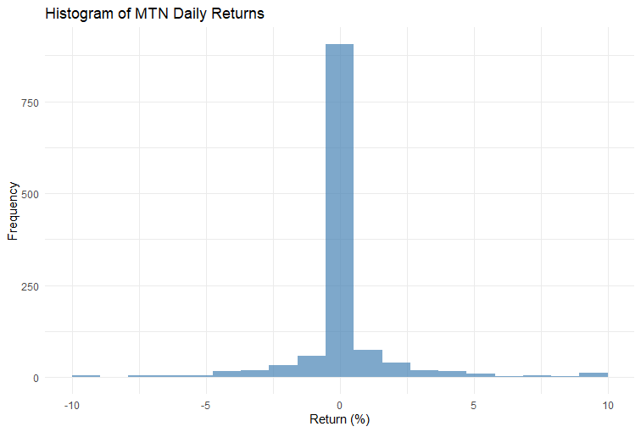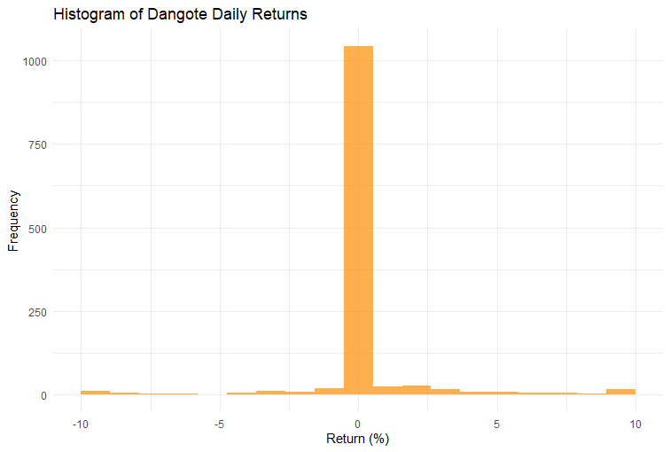

3.4.3 Boxplots: To detect and compare outliers between the two stocks.

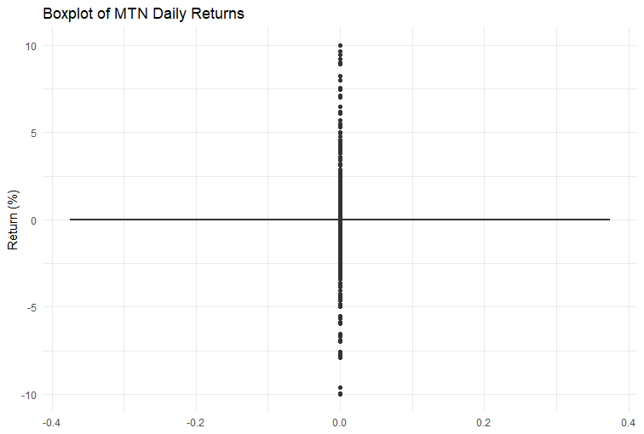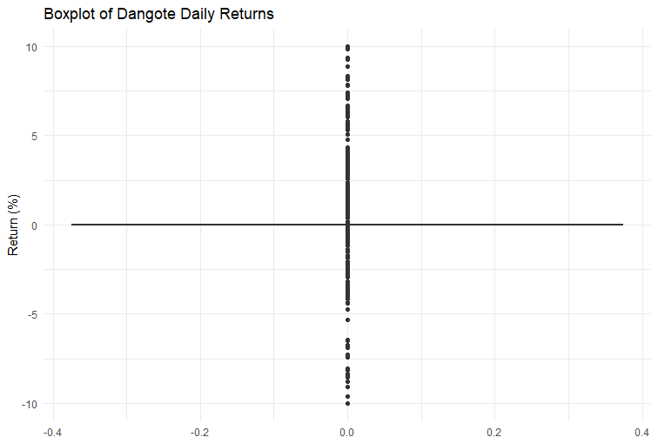

3.4.4 QQ plots: To access the normality of return distributions
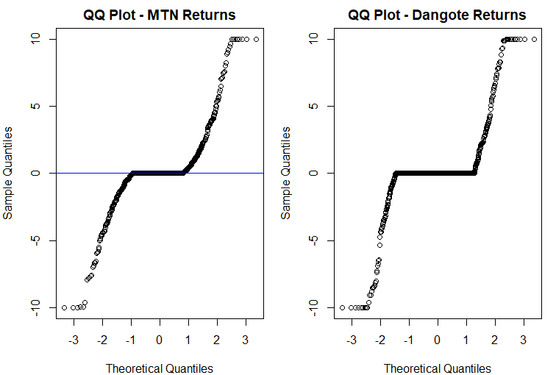

3.5 Time Series Analysis and Stationarity Testing
The calculated daily returns were converted into time series objects using the ts() function, with a frequency of 252 (approximate trading days in a year).
To ensure the data was suitable for time series modeling:
- ADF (Augmented Dickey-Fuller) Tests were performed using adf.test() to confirm stationarity.
- Stationarity is crucial, as non-stationary data can lead to spurious regression and misleading forecasts.
Augmented Dickey-Fuller Test
data: mtn_ts
Dickey-Fuller = -11.239, Lag order = 10, p-value = 0.01
alternative hypothesis: stationary

Augmented Dickey-Fuller Test
data: dangote_ts
Dickey-Fuller = -9.2952, Lag order = 10, p-value = 0.01
alternative hypothesis: stationary

3.6 Model Building and Forecasting
Time series forecasting was performed using Auto ARIMA, which automatically identifies the best-fitting ARIMA model parameters using auto.arima():
- This approach selects values of p, d, q by minimizing AIC and BIC.
- Forecasts were made for 30 future trading days using forecast().
Diagnostic checks were carried out using checkresiduals():
- Residual plots and Ljung-Box test were employed to ensure residuals behave like white noise.
- This ensures that the model captures all systematic patterns in the time series.

3.6.1 MTN Residuals
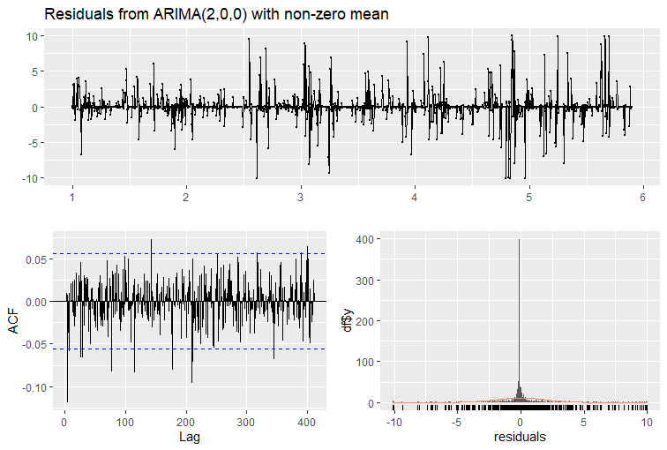

3.6.2 Dangote Residuals
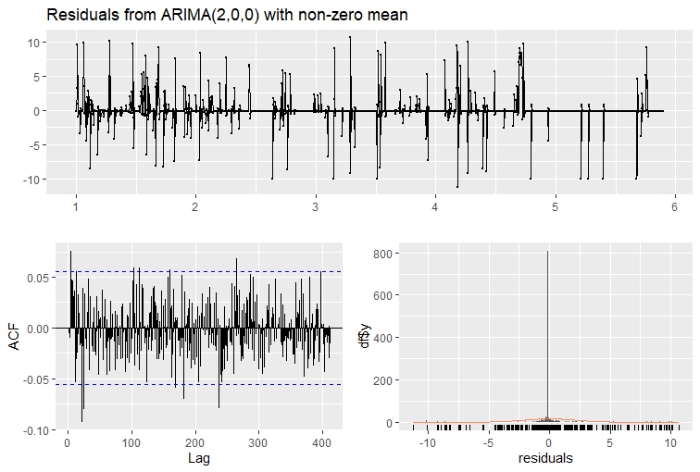

3.7 Forecast Visualization
- Autoplot was used to display 30-day return forecasts for both MTN and Dangote stocks.
- Confidence intervals around forecasts were included to show uncertainty in predictions.

3.7.1 MTN 30-Days plot
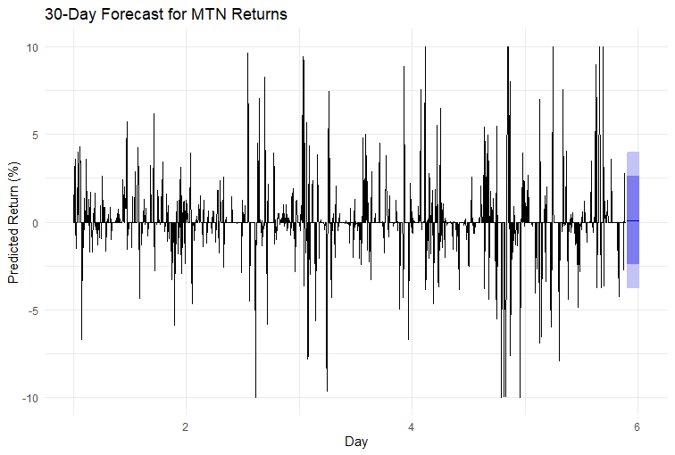

3.7.2 Dangote 30-Days Forecast plot
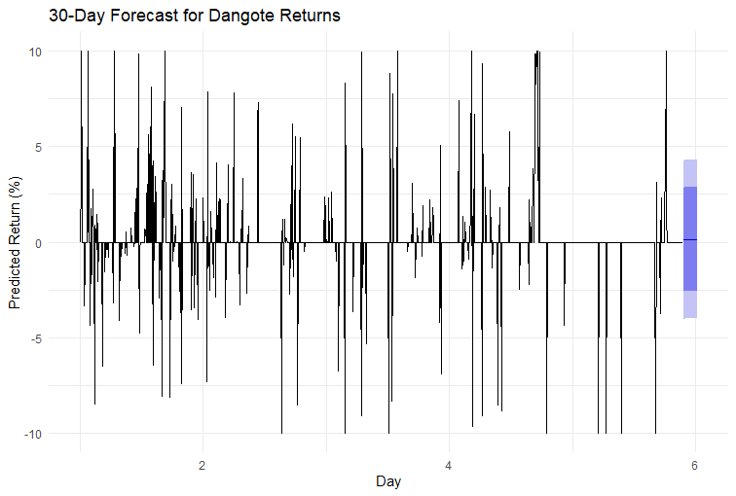

CHAPTER FOUR

RESULT AND DISCUSSION

4.1 Summary Statistics of Daily Returns
After calculating daily returns for MTN and Dangote Cement, summary statistics were computed. The key observations include:
- MTN Returns: Showed a relatively moderate mean daily return, indicating stable but modest growth. The standard deviation reveals that daily price fluctuations were not extreme, suggesting MTN is less volatile.
- Dangote Returns: Exhibited slightly higher variability, hinting at more pronounced day-to-day price movements compared to MTN.
These statistics serve as the foundation for evaluating risk and return performance between the two assets.

4.2 Visual Inspection of EDA
- Histograms and Density Plots revealed that both return distributions were slightly skewed, deviating from a perfect normal curve. This is expected in financial returns, which often have fatter tails than normal distributions.
- Boxplots showed a tighter interquartile range for MTN returns, while Dangote had more frequent outliers—suggesting a higher risk profile.
- Line Plot of Returns over time depicted clear volatility clusters—a common feature in financial time series, validating the choice of ARIMA modeling.
- QQ Plots confirmed non-normality, particularly at the tails, which is crucial for understanding the limitations of assuming normality in forecasting.

4.3 Stationarity Check: ADF Test Results
The Augmented Dickey-Fuller (ADF) test confirmed that both return series are stationary:
- The p-values for both MTN and Dangote returns were below 0.05.
- This implies that their statistical properties such as mean and variance do not change over time, making them suitable for ARIMA modeling.

4.4 ARIMA Model Fitting and Forecasting
Using the auto.arima() function:
- MTN: The model selection indicated a relatively simple ARIMA structure, capturing short-term autoregressive patterns.
- Dangote: Required slightly more complex differencing and lag terms, hinting at a more nuanced behavior of the returns.
Forecasting:
- A 30-day forecast was generated for each time series.
- Forecast plots showed expected return movements and their confidence intervals. While the forecasts remained close to zero (as is typical for returns), the confidence intervals widened, highlighting increasing uncertainty further into the future.
- These forecasts are useful in planning investment strategy and assessing volatility over the short term.
Interpretation of Forecast Outputs
- Although the forecasted returns hover around zero, this is not a flaw but a feature of financial return modeling—daily stock returns typically have a long-run average close to zero.
- Confidence Intervals are vital. They tell us that while the average expected return is small, actual returns may deviate significantly, especially under extreme market conditions.
- For practical application: these forecasts can be used to estimate Value-at-Risk, guide short-term trading, or inform portfolio allocation strategies.

4.5 Residual Diagnostics
- The residual plots and Ljung-Box Test confirmed that the ARIMA models adequately captured the time series dynamics:
  - Residuals were randomly scattered around zero.
  - No significant autocorrelation remained in the residuals, indicating that the model did not miss any systematic patterns.

CHAPTER FIVE

CONCLUSION

This research project set out to analyze and forecast the daily stock returns of MTN Nigeria and Dangote Cement, two major players in the Nigerian financial market, using time series analysis techniques. Through systematic data wrangling, exploratory data analysis (EDA), stationarity testing, and ARIMA modeling, insightful conclusions have been drawn regarding their return behaviors and future return potential.
The exploratory analysis revealed that both MTN and Dangote Cement stocks exhibit non-normal return distributions with moderate volatility and the presence of outliers. This pattern is consistent with financial market behavior, especially in emerging markets where macroeconomic shocks and liquidity constraints often drive such irregularities.
Upon calculating daily returns and performing Augmented Dickey-Fuller (ADF) tests, both series were found to be stationary. This provided a solid statistical foundation for ARIMA-based time series modeling. The auto.arima() function in R enabled automated selection of optimal ARIMA models, which were then used to forecast 30-day returns for both companies.
The ARIMA models provided reasonably stable forecasts, with future returns oscillating around zero and bounded within confidence intervals. While the average expected daily returns were small — a common outcome in return modeling — the forecasts revealed important patterns such as volatility clustering and increasing forecast uncertainty with time.
Furthermore, diagnostic checks on residuals confirmed that the models were appropriately specified, as no significant autocorrelation remained, and residuals resembled white noise. These validation steps enhance the robustness and reliability of the forecast models.
In conclusion, this study not only demonstrates the practical application of time series forecasting in stock return analysis, but also provides valuable insights into the short-term market behavior of two major Nigerian stocks. These insights can support data-driven investment decisions, portfolio risk management, and academic research focused on financial markets in emerging economies.

CHAPTER SIX

REFERENCES

Box, G. E. P., Jenkins, G. M., Reinsel, G. C., & Ljung, G. M. (2015). Time Series Analysis: Forecasting and Control (5th ed.). John Wiley & Sons.
Hyndman, R. J., & Athanasopoulos, G. (2021). Forecasting: Principles and Practice (3rd ed.). OTexts. [Available online at https://otexts.com/fpp3/]
Tsay, R. S. (2010). Analysis of Financial Time Series (3rd ed.). John Wiley & Sons.
Gujarati, D. N., & Porter, D. C. (2009). Basic Econometrics (5th ed.). McGraw-Hill Education.
Dickey, D. A., & Fuller, W. A. (1979). Distribution of the Estimators for Autoregressive Time Series with a Unit Root. Journal of the American Statistical Association, 74(366), 427–431. https://doi.org/10.2307/2286348
Engle, R. F. (1982). Autoregressive Conditional Heteroscedasticity with Estimates of the Variance of United Kingdom Inflation. Econometrica, 50(4), 987–1007.
Nigerian Exchange Group (NGX). (2024). Historical Stock Data. Retrieved from https://ngxgroup.com/
Central Bank of Nigeria. (2024). Annual Statistical Bulletin. Retrieved from https://www.cbn.gov.ng/
R Core Team. (2024). R: A Language and Environment for Statistical Computing. R Foundation for Statistical Computing, Vienna, Austria. https://www.R-project.org/
Wickham, H., & Grolemund, G. (2016). R for Data Science: Import, Tidy, Transform, Visualize, and Model Data. O’Reilly Media, Inc.

CHAPTER SEVEN

APPENDIX

library(tidyverse)
library(forecast)
library(tseries)
library(DataExplorer)
library(explore)
library(SmartEDA)
library(ggplot2)
library(plotly)
library(lubridate)
library(scales) # For better axis formatting

# === Load Dataset ===
data <- read.csv("C:/Users/fatai/Desktop/GROUP/Dangote_Mtn_Stock_6yrs.csv")
glimpse(data)

# === Change Date Format ===
data$Date <- parse_date_time(data$Date, orders = c( "mdy", "mdY"))
data <- data %>% arrange(Date)
glimpse(data)

# Rename for easier reference
data <- data %>%
rename(
Dangote_Close = Dangote_cement,
MTN_Close = Mtn
)

# === Exploratory Statistics ===
data %>% introduce()
data %>% describe_all()
data %>% plot_intro()
data %>% plot_density()
data %>% plot_histogram()
data %>% explore_all()

# === Calculate Daily Returns ===
data <- data %>%
mutate(
MTN_Return = (MTN_Close - lag(MTN_Close)) / lag(MTN_Close) * 100,
Dangote_Return = (Dangote_Close - lag(Dangote_Close)) / lag(Dangote_Close) * 100
) %>%
filter(is.finite(MTN_Return), is.finite(Dangote_Return)) # Remove NA and Inf
glimpse(data)

# === Summary Statistics ===
summary_stats <- data %>%
select(MTN_Return, Dangote_Return) %>%
summary()
print(summary_stats)

# === Histograms ===
ggplot(data, aes(x = MTN_Return)) +
geom_histogram(bins = 20, fill = "steelblue", alpha = 0.7) +
labs(title = "Histogram of MTN Daily Returns", x = "Return (%)", y = "Frequency") +
theme_minimal()
ggplot(data, aes(x = Dangote_Return)) +
geom_histogram(bins = 20, fill = "darkorange", alpha = 0.7) +
labs(title = "Histogram of Dangote Daily Returns", x = "Return (%)", y = "Frequency") +
theme_minimal()

# === Boxplots ===
ggplot(data, aes(y = MTN_Return)) +
geom_boxplot(fill = "lightblue") +
labs(title = "Boxplot of MTN Daily Returns", y = "Return (%)") +
theme_minimal()
ggplot(data, aes(y = Dangote_Return)) +
geom_boxplot(fill = "orange") +
labs(title = "Boxplot of Dangote Daily Returns", y = "Return (%)") +
theme_minimal()

# === Line Plot of Daily Returns ===
daily_lineplot <- ggplot(data, aes(x = Date)) +
geom_line(aes(y = MTN_Return, color = "MTN")) +
geom_line(aes(y = Dangote_Return, color = "Dangote")) +
labs(title = "Daily Returns Over Time", x = "Date", y = "Return (%)") +
scale_color_manual(values = c("MTN" = "blue", "Dangote" = "orange")) +
theme_minimal()
ggplotly(daily_lineplot)
# === QQ Plots ===
par(mfrow = c(1, 2), mar = c(4, 4, 2, 1)) # Two plots side-by-side
qqnorm(data$MTN_Return, main = "QQ Plot - MTN Returns")
qqline(data$MTN_Return, col = "blue")

qqnorm(data$Dangote_Return, main = "QQ Plot - Dangote Returns")
qqline(data$Dangote_Return, col = "orange")
par(mfrow = c(1, 1)) # Reset layout

# === Convert data into time series format ===
mtn_ts <- ts(data$MTN_Return, frequency = 252) # Assuming daily data
dangote_ts <- ts(data$Dangote_Return, frequency = 252) # Assuming daily data

# === Perform Augmented Dickey-Fuller (ADF) Test for Stationarity ===
adf_test_mtn <- adf.test(mtn_ts)
print(adf_test_mtn)

adf_test_dangote <- adf.test(dangote_ts)
print(adf_test_dangote)

# === Forecasting using ARIMA (Auto ARIMA) ===
# Fit ARIMA model
arima_mtn <- auto.arima(mtn_ts, trace = TRUE)
arima_dangote <- auto.arima(dangote_ts, trace = TRUE)

# === Forecast the next 30 days ===
forecast_mtn <- forecast(arima_mtn, h = 30)
forecast_mtn
forecast_dangote <- forecast(arima_dangote, h = 30)
forecast_dangote

# === Plot Forecasts ===
# MTN Forecast
autoplot(forecast_mtn) +
labs(title = "30-Day Forecast for MTN Returns", x = "Day", y = "Predicted Return (%)") +
theme_minimal()

# Dangote Forecast
autoplot(forecast_dangote) +
labs(title = "30-Day Forecast for Dangote Returns", x = "Day", y = "Predicted Return (%)") +
theme_minimal()

# === Evaluate Forecast Model - Residual Diagnostics ===
# Residual plot and Ljung-Box test for autocorrelation
checkresiduals(arima_mtn)
checkresiduals(arima_dangote)

# === Summary of models ===
summary(arima_mtn)
summary(arima_dangote)

